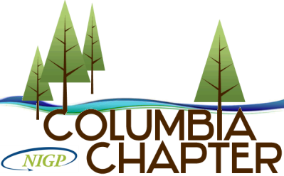
National Institute of Governmental Purchasing - Columbia Chapter
Serving the Greater Portland Area and Southwest Washington.

MEMBERSHIP APPLICATION
An individual application must be filled out by each applicant.

NAME (print/type): ________________________________________________________________________________

POSITION/TITLE: ________________________________________________________________________________

AGENCY: _____________________________________ DEPT: ___________________________________________

ADDRESS: _____________________________________________________________________________________

PHONE: ______________________________________ EMAIL: __________________________________________

CURRENT CERTIFICATION: NIGP-CPP , CPPO , CPPB , CPM , OTHER: _______________________

MEMBER OF NIGP NATIONAL:

Provide a description of your purchasing functions.

______________________________________________________________________________________________

Do you have an area of expertise that you would like to share with the membership?

______________________________________________________________________________________________
If admitted to membership, I agree to abide by the Rules and Regulations and Ethics of NIGP and the Columbia Chapter. I agree to resign from the chapter in case my duties of employment change and I am no longer qualified to hold membership
SIGNATURE OF APPLICANT______________________________________________________________________
SUPERVISOR/MANAGER SIGNATURE______________________________________________________________
Membership Fee $100.00
Upon review and approval of your application, the Columbia Chapter will send you an invoice for the membership fee.
Please email the completed application to Tessa Paul, Membership Director, at tessa.paul@multco.us.

