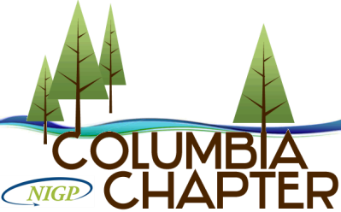
National Institute of Governmental Purchasing - Columbia Chapter
Serving the Greater Portland Area and Southwest Washington.

MEMBERSHIP APPLICATION
An individual application must be filled out by each applicant.

NAME (print/type): ________________________________________________________________________________

POSITION/TITLE: ________________________________________________________________________________

AGENCY: _____________________________________ DEPT: ___________________________________________

ADDRESS: _____________________________________________________________________________________

PHONE: ________________________________________ EMAIL: ________________________________________

PRESENT CERTIFICATION: ______ NIGP-CPP ______CPM _____CPPO _____CPPB _____OTHER

MEMBER OF NIGP NATIONAL: Yes_____ No ______

Provide a description of your purchasing functions (attach additional if necessary)
______________________________________________________________________________________________

______________________________________________________________________________________________

Do you have an area of expertise that you would like to share with the membership?
______________________________________________________________________________________________
______________________________________________________________________________________________

If admitted to membership, I agree to abide by the Rules and Regulations and Ethics of NIGP and the Columbia Chapter. I agree to resign from the chapter in case my duties of employment change and I am no longer qualified to hold membership
SIGNATURE OF APPLICANT______________________________________________________________________
SUPERVISOR/MANAGER APPROVAL______________________________________________________________

Membership Fee $100.00 - No Payment at this time.
Upon review and approval of your application, the Columbia Chapter will send you an invoice for the membership fee.

Please email the completed application to Tessa Paul, Membership Director, at tessa.paul@multco.us.

