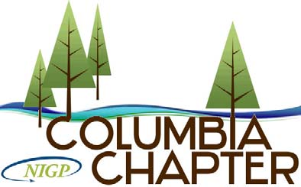

COLUMBIA CHAPTER NIGP
2017 APPLICATION FOR REWARDS

APPLICATION COVER SHEET

I. General Information

a. Applications, completed in their entirety, must be received by February 17, 2017.
b. Information contained within the application must be from the previous calendar year.
c. Applications may be faxed or emailed.
d. Submit completed Application Cover Sheet and Activity Point Schedule to the Columbia Chapter Past President James C. Moering by email: james.moering@portlandoregon.gov

II. Applicant Information:

Name:
Agency:
Address:
Telephone:
E-mail:

III. Affirmation Statement

I hereby affirm that the information throughout this application is true and correct to the best of my knowledge and that any falsification or willful misstatements or omissions may forfeit my rights to Columbia Chapter NIGP Rewards.

_____________________________________________ _______________
Applicant Signature Date

ACTIVITY POINT SCHEDULE
ACTIVITY | POINTS PER ACTIVITY | MAXIMUM POINTS ALLOWED (per year) | POINTS EARNED
Attended Reverse Vendor Trade Show (full day attendance) | 7 | 7
Attended Reverse Vendor Trade Show (half day attendance) | 3 | 3
Participation in Chapter Service Project | 5 | 5
Submit article, bio, or story for Chapter Website | 2 points per article | 6
Columbia Chapter Board Member | 4 | 4
Committee Chair* | 3 | 3
Committee Member* | 2 | 2
Manager of Year Recognition | 3 | 3
Buyer of Year Recognition | 3 | 3
Attended NIGP sponsored Webinar | 1 | 3
Attend NIGP sponsored 1-day class* | 2 | 6
Attend NIGP sponsored 2-day class* | 4 | 12
Attend NIGP sponsored 3-day class* | 6 | 18
Attend General Meeting (6 regular lunch meetings) | 2 points per meeting | 12
Attended ICP meeting (8 meetings) | 1 point per meeting | 8
Attend Columbia Chapter workshop (full day) | 4 | 4
Attend Joint Workshop (with OPPA) | 4 | 4
Attendance at Forum | 5 | 5
CPPB Certification/Re-certification | 3 | 3
CPPO Certification/Re-certification | 3 | 3
Renew Chapter Membership | 5 | 5
New Chapter Membership | 5 | 5
Renew National Membership | 5 | 5
New National Membership | 5 | 5
Silent Auction Donation | 6 | 6
Total Points

Please list the committees and classes representing the points above:

